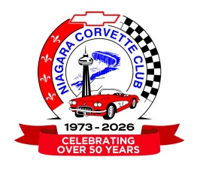
Niagara Corvette Club Sponsor Form
Sponsorship Donations will receive a business invoice eligible for business expense deductions.

Recognition of sponsorship on Car Show promotional material and listed on our website (business card or logo with a link to your website) and Facebook page for the whole year, as well as in our quarterly newsletter.

Gold Sponsorship – $250 and up
First Name Last Name
Email Address
Company
Company Website

Please provide your logo or business card graphic to use for the rotating ad display on the website.
Please email a jpg or png image to infomgmt@niagaracorvetteclub.com

Street Address

Street Address Line 2

City Province
Postal Code Phone #

Please indicate whether you would like your receipt in your personal name, or company name.

Personal Name Company Name

Please send an e-Transfer to treasurer@niagaracorvetteclub.com (auto-deposit is enabled so a password is not required).

Please contact Sponsorship Director Paul Toth (sponsorship@niagaracorvetteclub.com) if you would like to discuss our sponsorship program in greater detail, or in person, or if you would like to arrange for an alternate payment method.

